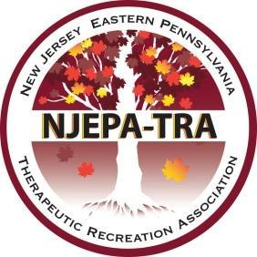
The New Jersey Eastern Pennsylvania Therapeutic Recreation Association’s 22nd Annual Fall Conference
VIRTUAL
Monday, November 16 – Tuesday, November 17, 2020

Speaker Application
Please complete this application in its entirety before August 15, 2020!
Incomplete applications will not be accepted.
Speaker’s Name:
Speaker’s Address:
Daytime Phone #: | Email:
Relevant Audience (Check all that apply.)
__Entry level therapist __Advanced therapist __Student:______________ __Educator:_____________
__Entry level supervisor __Advanced supervisor __Other (Indicate): __________________
Target Population (Check all that apply.)
__Long-Term Care __Assisted Living __Adult Medical Day Pediatrics____
__Rehabilitation __Hospital __Psychiatric __Other (indicate): _____________________
Length of Session: __1.5 hours __ 3 hours(2 parts) __4.5 hours(3 parts)
Resource list (books, journal articles, other publications)
Speaker’s Introductory Bio and Photo: (Limit to 100 Words. Include Speaker Qualifications.)

Title of Session:

Session Description:

Learning Outcomes:
By the end of the session the CTRS will be able to…(Learner outcomes must be measurable.)

Session Outline (Include time frames for each section of your presentation. Total session time must equal a minimum of 90 minutes)
- Intro (10 minutes)
a.
b.
c.

NCTRC Job Analysis Area (Check all that apply.) See NCTRC’s publication here for more information.
___ Foundational Knowledge (FKW)
___ Assessment Process (ASP)
___ Documentation (DOC)
___ Implementation (IMP)
___ Administration of TR/RT Programs (ADM)
___ Advancement of the Profession (ADV)

Instructional Method: (Check all that apply.)
__Lecture
__Discussion
__Panel
__Interactive activities

Under the guidance of the NJEPA-TRA Board of Directors and/or Education Committee are you willing to record this VIRTUAL learning opportunity? __Yes __No

SUBMIT THIS COMPLETED APPLICATION IN MICROSOFT WORD FORMAT
AND EMAIL TO:
education.njepatra@gmail.com

