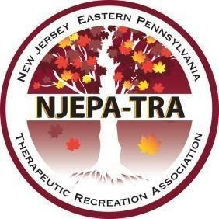

The New Jersey - Eastern Pennsylvania Therapeutic Recreation Association’s 2023 Spring Workshop
March 10, 2023, at Kean University Union, NJ

Speaker Application

Please complete this application in its entirety. Incomplete applications will not be accepted.
SSpeaker’s Name:
SSpeaker’s Address:
Daytime Phone #: | Time Slot Preferred:  _ __AM _ __PM  No Preference: ___ | Email:
Relevant Audience (Check all that apply.)
__Entry level therapist __Advanced therapist __Student:______________ ____Educator:_____________
__Entry level supervisor __Advanced supervisor __Other (Indicate): __________________
Target Population (Check all that apply.)
__Long-Term Care __Assisted Living __Adult Medical Day Pediatrics____
__Rehabilitation __Hospital __Psychiatric __Other (indicate): _____________________
Length of Session: __1.5 hours __ 3 hours(2 parts) __4.5 hours(3 parts)
Comments or special needs:
Resource list (books, journal articles, other publications)
Speaker’s Introductory Bio: (Include Speaker Qualifications.)

Title of Session:

Session Description:

Learning Outcomes:
By the end of the session the CTRS will be able to…(Learner outcomes must be measurable.)

Session Outline (Include time frames for each section of your presentation. Total session time must equal a minimum of 90 minutes)
- Intro (10 minutes)
a.
b.
c.

NCTRC Job Analysis Area (Check all that apply.)
___ Foundational Knowledge (FKW)
___ Assessment Process (ASP)
___ Documentation (DOC)
___ Implementation (IMP)
___ Administration of TR/RT Programs (ADM)
___ Advancement of the Profession (ADV)

Instructional Method: (Check all that apply.)
__Lecture
__Discussion
__Panel
_ _Interactive activities

SEND COMPLETED APPLICATION
BY MONDAY, JANUARY 23RD IN MICROSOFT WORD FORMAT TO:

Lacey Speert and NJEPA-TRA Education Committee

education.njepatra@gmail.com

Please be prepared to submit a copy of your session two weeks before March 10, 2023

