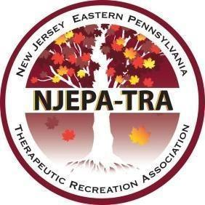

The New Jersey - Eastern Pennsylvania Therapeutic Recreation Association’s 2023 Annual Fall Conference
November 13, 2023, at the Holiday Inn East Windsor, NJ and Virtual Sessions from November 14-December 14th
Submissions due by August 1, 2023

Speaker Application

Please complete this application in its entirety. Incomplete applications will not be accepted.
SSpeaker’s Name:
SSpeaker’s Address:
Daytime Phone #: | Time Slot Preferred:  _ __AM _ __PM __  No Preference: ___  {  Virtual presentation ___ | Email:
Relevant Audience (Check all that apply.)
__Entry level therapist __Advanced therapist __Student:______________ ____Educator:_____________
__Entry level supervisor __Advanced supervisor __Other (Indicate): __________________
Target Population (Check all that apply.)
__Long-Term Care __Assisted Living __Adult Medical Day Pediatrics____
__Rehabilitation __Hospital __Psychiatric __Other (indicate): _____________________
Length of Session: __1.5 hours __ 3 hours(2 parts) __4.5 hours(3 parts)
Comments or special needs:
Resource list (books, journal articles, other publications)
Speaker’s Introductory Bio: (Include Speaker Qualifications.)

Title of Session:

Session Description:

Learning Outcomes:
By the end of the session the CTRS will be able to…(Learner outcomes must be measurable.)

Session Outline (Include time frames for each section of your presentation. Total session time must equal a minimum of 90 minutes)
- Intro (10 minutes)
a.
b.
c.

NCTRC Job Analysis Area (Check all that apply.)
___ Foundational Knowledge (FKW)
___ Assessment Process (ASP)
___ Documentation (DOC)
___ Implementation (IMP)
___ Administration of TR/RT Programs (ADM)
___ Advancement of the Profession (ADV)

Instructional Method: (Check all that apply.)
__Lecture
__Discussion
__Panel
_ _Interactive activities
__ Pre-recorded virtual session (lecture)

SEND COMPLETED APPLICATION
BY TUESDAY, AUGUST 1, 2023 IN MICROSOFT WORD FORMAT TO:

NJEPA-TRA Education Committee

education.njepatra@gmail.com

Please be prepared to submit a copy of your session two weeks before November 13, 2023
Please be prepared to send a video of your pre-recorded virtual session by October 13, 2023
Thank you!

